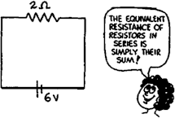
Electrical Circuits W.S.

- In the circuit shown at the right, a voltage of 6 V pushes charge through a single resistor of 2 W. According to Ohm's law, the current in the resistor, and therefore in the whole circuit, is A.

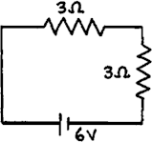
- If a second identical lamp is added, as on the left, the 6-V battery must push charge through a total resistance of ohms.

- The current in the circuit is then A.

- The equivalent resistance of three 4-ohm resistors in series is ohm(s).

- Does current flow through a resistor or across a resistor?

through | across

- Is voltage established through a resistor or across a resistor?

through | across

- Does current in the lamps occur simultaneously, or does charge flow first through one lamp, then the other, and finally the last in turn?

simultaneously | one at a time

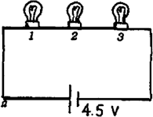
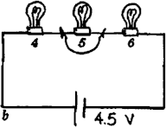
Refer to the following information for the next seven questions.

8. Circuits a and b below are identical with all bulbs rated at equal wattage and therefore equal resistance. The only difference between the circuits is that Bulb 5 has a short circuit, as shown.

- In which circuit is the current greater?

circuit a | circuit b

- In which circuit are all three bulbs equally bright?

circuit a | circuit b

- In which circuit are the bulbs the brightest?

circuit a | circuit b

- When both circuits are operating, which bulb(s) is(are) the dimmest?

#1 | #2 | #3 | #4 | #5 | #6

- What bulbs have the largest voltage drops across them?

1, 2, 3 | 4, 6 | 5

- Which circuit dissipates more power?

circuit a | circuit b

- What circuit produces more light?

circuit a | circuit b

9. Are auto headlights wired in series or in parallel? How you would you find out if weren’t sure?
Refer to the following information for the next eight questions.

10. Fill in the current in the eight blank spaces in the view of the same circuit shown again at the left. Start with the lower left hand corner and work clockwise.

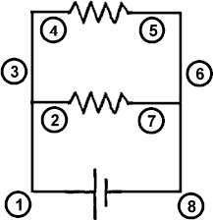
1’.

2’.

3’.
4’.

5’.

6’.

7’.

8’.
Refer to the following information for the next question.

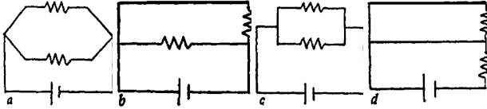
11. Which circuit shown in the following row is NOT equivalent to the circuit shown above?

Refer to the following information for the next five questions.

12. Consider the parallel circuit shown below and to the right.
- The voltage drop across each resistor is how many volts?

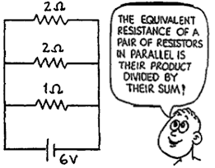
- The current in each branch containing a 2- ohm resistor is:

- The current in the branch containing a 1- ohm resistor is:

- The current through the battery, measured in amps, equals the sum of the currents which is:

- The equivalent resistance of the circuit equals how many ohms?

Calculate the power consumed in each resistor. Compare this value with the power delivered by the power supply by recording the voltage and current on the power supply. Place your answers in the tables provided.

Circuit #1

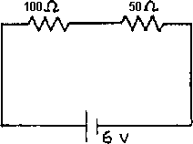

R
(ohms) 100

I (amps) V (volts) P (watts)

50

Power supply

Circuit #2

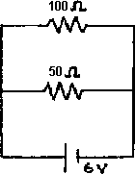

R (ohms) I (amps) V (volts) P (watts) 50

100

Power supply

Circuit #3

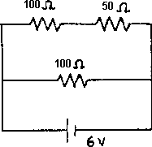

R (ohms) I (amps) V (volts) P (watts) 100 (upper)

50 (upper)

100 (lower) Power supply

Circuit #4

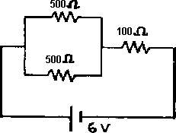

R (ohms) I (amps) V (volts) P (watts) 500 (upper)

500 (lower)

100

Power supply

Refer to the following information for the next seven questions.

Assume that all bulbs have filaments that are the same length.
- Which statement is true of generic light bulbs that are rated at 40 watts and 75 watts when tested in 120-V outlets?

The 40 watt bulb has a thinner filament and therefore less resistance.
The 75 watt bulb has a thinner filament and therefore less resistance.
The 75 watt bulb has a thicker filament and therefore less resistance.
The 40 watt bulb has a thicker filament and therefore less resistance.

- Two lamps, one with a thick filament and the other with a thin filament are connected in parallel. The current is greater in the lamp with the

thin filament | thick filament | the same in each lamp

- Two lamps, one with a thick filament and the other with a thin filament are connected in series to a battery. The voltage drop is greater in the lamp with the

thin filament | thick filament | the same in each lamp

- Two lamps, one with a thick filament and the other with a thin filament are connect in series. The current is greater in the lamp with the

thin filament | thick filament | the same in each lamp

- Two lamps, one with a thick filament and the other with a thin filament are connect in parallel across a battery. The voltage drop is greater in the lamp with the

thin filament | thick filament | the same in each lamp

- As more and more lamps are connected in a parallel circuit, the overall current drawn from the battery

decreases | remains the same | increases

- As more and more lamps are connected in a series circuit, the overall current drawn from the battery

decreases | remains the same | increases

Refer to the following information for the next eleven questions:

In each of the following diagrams all batteries have the same voltage and all lamps are identical
- Compared to A, lamp B would shine
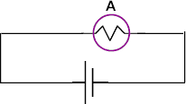
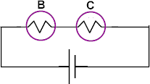

brighter | the same brightness | dimmer

- Compared to A, lamp B would shine
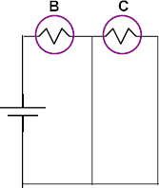

brighter | the same brightness | dimmer

- Compared to A, lamp B would shine
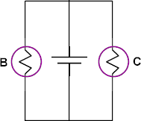

brighter | the same brightness | dimmer

24.. Compared to A, lamp B would shine
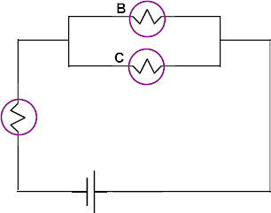

brighter | the same brightness | dimmer

25. Compared to A, lamp B would shine
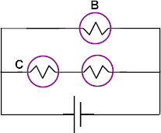

brighter | the same brightness | dimmer

26.. Compared to A, lamp B would shine
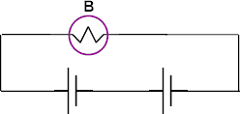

brighter | the same brightness | dimmer

- Compared to A, lamp B would shine
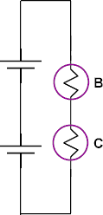

brighter | the same brightness | dimmer

- Compared to A, lamp B would shine
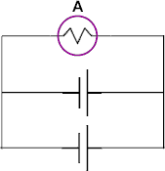
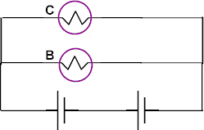

brighter | the same brightness | dimmer

- Compared to A, lamp B would shine
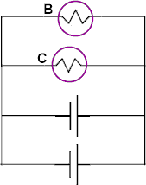

brighter | the same brightness | dimmer

- Compared to A, lamp B would shine
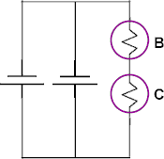

brighter | the same brightness | dimmer

- Compared to A, lamp B would shine
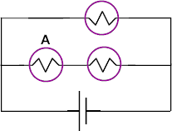

brighter | the same brightness | dimmer

Why can birds sit on high-voltage power lines (which are bare and have no insulation) and not be electrocuted?

- An old saying used by people who work around electrical voltages is, “You should keep one hand in your pocket”. What is the reason for this saying.

A foolhardy and dangerous thing to do when no spare Edison-base fuses are available is to put a penny in the socket behind the blown fuse. Why is this dangerous?

